Data Mining Final Project
Telecom Customer Churn Classification

1. Problem Definition and Objectives
This project predicts whether a telecommunications customer will churn based on demographic, service, account, tenure, and billing information. The research question is: Can customer characteristics and service/account information be used to classify customers as likely to churn or remain? This is a supervised binary classification task, with Churn = Yes as the positive class. The practical objective is to identify customers who may need retention actions while comparing a from-scratch decision tree with an additional machine-learning model.

2. Dataset Description
The project uses the IBM Telco Customer Churn dataset. The CSV contains 7,043 customer records and 21 columns, including a customer identifier, demographic and service attributes, account/billing variables, and the binary target Churn. It exceeds the assignment minimum of 300 rows and five predictive features and contains both categorical and continuous attributes. IBM documents this Telco Churn sample as data tracking whether customers departed within the last month.
Sources: IBM Telco Customer Churn documentation: https://www.ibm.com/docs/en/cognos-analytics/12.0.x?topic=samples-telco-customer-churn
Kaggle IBM dataset: https://www.kaggle.com/datasets/yeanzc/telco-customer-churn-ibm-dataset

3. Data Loading and Preprocessing
The raw data was loaded and summarized before modeling. TotalCharges was originally text, so it was converted to numeric; 11 blank/invalid entries became missing values. No duplicate rows were found. customerID was treated as an identifier and excluded from model features. Variables were classified as nominal, ordinal, or ratio/continuous. Contract was recognized as ordinal, while tenure, MonthlyCharges, and TotalCharges were treated as continuous.
Missing TotalCharges values were assigned with the training-set mean (2,305.07). The code calculates this value from training data and applies the same value to the test set, avoiding test-set leakage. A stratified 70/30 train/test split was used with random_state=42.
The IQR outlier check reported zero outliers for tenure, MonthlyCharges, and TotalCharges under the implemented 1.5×IQR rule. PCA on the three continuous variables produced explained-variance ratios of approximately 99.986% and 0.012% for the first two components. PCA was not used as the final feature representation because the dataset is not high-dimensional and the original variables are more interpretable.

4. Class Imbalance
The target distribution was 5,174 No-churn customers (73.47%) and 1,869 churn customers (26.53%), giving a majority/minority ratio of 2.77:1. This exceeds the project's approximately 70/30 imbalance flag. Random oversampling was therefore applied only to the training set: 4,930 training rows became 7,244, while the test set remained at its original distribution.

5. Exploratory Data Analysis
EDA was performed on cleaned training data. Tenure had mean 32.47 months and median 29 months. MonthlyCharges had mean 64.95 and median 70.58. TotalCharges had mean 2,305.07, median 1,390.73, and standard deviation 2,290.92, indicating strong right skew. The required histogram, box plot, and scatter matrix were generated.
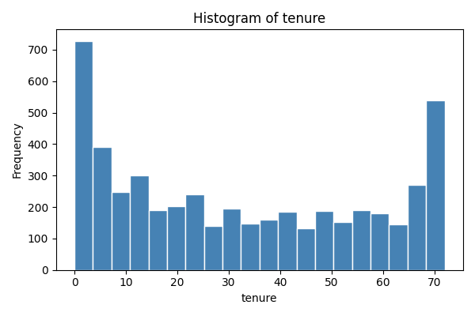
Figure 1. Histogram generated by the EDA pipeline.
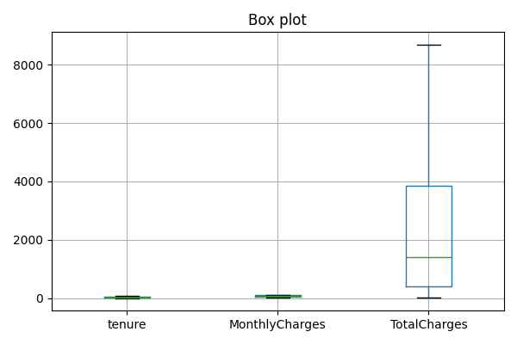
Figure 2. Box plots of the three continuous attributes.
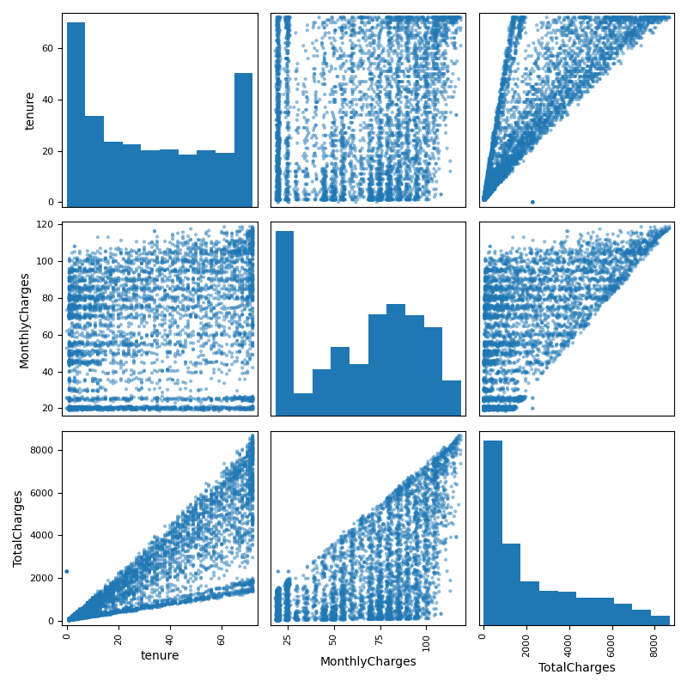
Figure 3. Scatter matrix of the key continuous attributes.

6. Modeling Approach
Two model families were compared. The first was a from-scratch decision tree using the course's impurity and splitting logic. Both Gini and Entropy/Information Gain versions were trained with maximum depth 6. Categorical attributes were split by category, while tenure, MonthlyCharges, and TotalCharges used binary threshold splits. As a sanity check, the implementation reproduced the expected Play Tennis parent values: Gini ≈ 0.4592 and Entropy ≈ 0.9403. For the Telco data, the best tenure threshold was 22.5 months with information gain 0.0933. If a category value appears at prediction time that the tree never saw during training, the tree falls back to that node’s majority class rather than failing, so a prediction is always returned.
The additional model was k-nearest neighbors (k=5) using Euclidean distance. This connects directly to the course's similarity/distance work. Categorical features were one-hot encoded and continuous features standardized before k-NN, making Euclidean distance more appropriate across different scales.

7. Test-Set Results
Model | Accuracy | Precision | Recall | F1 | Cost | Confusion matrix
Gini tree | 72.55% | 0.4897 | 0.8039 | 0.6086 | 1020 | [[451,110],[470,1082]]
Entropy tree | 73.45% | 0.5000 | 0.7914 | 0.6128 | 1029 | [[444,117],[444,1108]]
k-NN (k=5) | 69.00% | 0.4485 | 0.7291 | 0.5553 | 1263 | [[409,152],[503,1049]]
The test set contained 2,113 customers. All three models were trained on the identical stratified 70/30 split (random_state=42) and evaluated on this same held-out test set, so the comparison below is apples-to-apples. Entropy achieved the highest test accuracy (73.45%) and F1 (0.6128). Gini achieved slightly higher recall (80.39%) and the lowest asymmetric cost (1,020), because the cost function penalized missed churners five times more than false churn alerts. k-NN was lower on every primary test metric.

8. Cross-Validation and Learning Curves
Model | 5-fold accuracies | Mean
Gini tree | 0.7709, 0.7750, 0.7840, 0.7964, 0.7686 | 0.7790
Entropy tree | 0.7943, 0.7785, 0.7785, 0.7902, 0.7686 | 0.7820
k-NN | 0.7619, 0.7619, 0.775, 0.7971, 0.7604 | 0.7713
Five-fold cross-validation supports the test-set conclusion: Entropy had the highest mean accuracy (78.20%), followed by Gini (77.90%) and k-NN (77.13%). The pipeline also generated learning curves for k-NN and the Entropy tree to examine training/validation behavior as the training-set size increases.
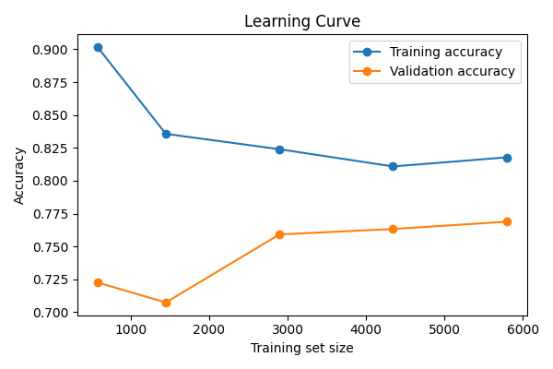
Figure 4. Learning curve for the from-scratch Entropy tree.
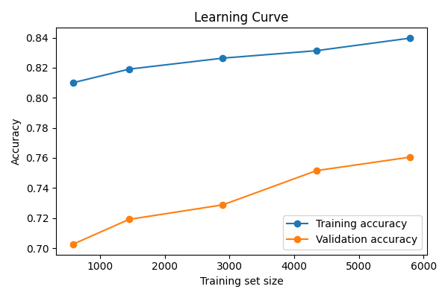
Figure 5. Learning curve for k-NN.

9. Discussion and Comparison
Overall, the Entropy-based decision tree is the strongest general-purpose model in this experiment. It produced the best test accuracy, precision, F1, and mean five-fold accuracy. Its F1 score of 0.6128 gives the best balance between identifying churners and limiting false-positive alerts among the tested models. Gini is a close alternative and is preferable if recall or the specified asymmetric cost is prioritized: it detected 80.39% of actual churners and achieved the lowest total cost.
The weaker k-NN result is plausible for this dataset. One-hot encoding creates a higher-dimensional space, and Euclidean distance can become less informative when many binary service indicators are combined. Decision trees can instead form direct rules around contract type, tenure, services, and charges. Both tree versions selected Contract as their root attribute, indicating that it was highly informative for the implemented splitting criterion.
Accuracy alone is not enough here. The original data has a 73.47% majority class, so a majority-class predictor would already obtain about 73.47% accuracy. Precision, recall, F1, confusion matrices, and cost-sensitive scoring therefore provide important additional information. Oversampling was correctly restricted to training data so the natural test distribution was preserved.

10. Limitations and Improvements
Future work could improve the evaluation by using stratified cross-validation and reporting F1/recall rather than accuracy alone during validation. Hyperparameter tuning could compare tree depth and different k values. EDA could also include churn-rate plots for categorical features and a correlation analysis. Finally, TotalCharges is cumulative with tenure and dominates numeric variance, so a deployment-oriented study should verify that every feature represents information available at the exact time a churn prediction would be made.

11. Conclusion
The submitted pipeline successfully combines the required data-mining stages on a real tabular dataset: data characterization, preprocessing, missing-value handling, duplicate and outlier checks, PCA, class-imbalance correction, EDA, from-scratch Gini and Entropy decision trees, k-NN, confusion-matrix metrics, cross-validation, and learning curves. The Entropy tree is the recommended overall model because it achieved the best test F1 and accuracy and the best mean cross-validation accuracy. The Gini tree remains appealing when maximizing recall or minimizing the specified business cost is more important.

References
IBM. Telco Customer Churn sample documentation. https://www.ibm.com/docs/en/cognos-analytics/12.0.x?topic=samples-telco-customer-churn
Kaggle. Telco customer churn: IBM dataset. https://www.kaggle.com/datasets/yeanzc/telco-customer-churn-ibm-dataset

